**Customer Retention Analysis**



Submitted by:

Rajashri Sadafule Darveshi

**ACKNOWLEDGMENT**

I would like to express my special thanks of gratitude to the sources Medium, Analytics Vidhya, TowardsDataScience, Data Training Projects and youtube channel’s which helped me to for this project. I would like to thank FlipRobo for giving me this opportunity to develop and accomplish this project.

**INTRODUCTION**

**Problem Statement:**

* The combination of both utilitarian value and hedonistic values are needed to affect the repeat purchase intention (loyalty) positively .
* The objective was to perform extensive data analysis on a given dataset and produce valuable insights that will help in customer retention.
* The dataset consist of 71 features and 269 rows

Customer satisfaction has emerged as one of the most important factors that guarantee the success of online store it has been posited as a key stimulant of purchase, repurchase intentions and customer loyalty.

A comprehensive review of the literature, theories and models have been carried out to propose the models for customer activation and customer retention.

Five major factors that contributed to the success of an e-commerce store have been identified as: service quality, system quality, information quality, trust and net benefit.

**Business Problem Framing**

The objective was to perform extensive data analysis on a given dataset and produce valuable insights that will help in customer retention

**Review Of Literature**

In today’s challenging economy and competitive business world, retaining their customer base is critical to organization success. If the company doesn’t give their customer some good reason to stay, organization’s competitors will give the customer a reason to leave. Customer retention and customer satisfaction drive profits. It’s far less expensive to cultivate organization existing customer base and sell more service to the customer than it to seek new, single-transaction customers. Most surveys across industries shows that keeping one existing customer is five to seven times more profitable than attracting one new customer. A customer-focused approach among its employees is still not present. In this era of intense competition .it is very important for any service company to understand that merely acquiring customer is not sufficient because there is a direct link between customer retention over time and profitability & growth. Customer retention to a great extent depends on service quality and customer satisfaction. Complaints are natural part of any service activity as mistakes are an unavoidable feature of all human endeavoured thus also of service recovery. Service recovery is the process of putting things right after something goes wrong in the service delivery. Customer retention is the maintenance of continuous trading relationships with customers over the long term

Customer retention is the mirror image of customer defection. High retention is equivalent to low defection. In an industry where there are a multiple purchases over the years, organization’s entire team should be very focused on retaining those customers:

i. Delivering service that’s consistent with your value proposition and brand

ii. Cross-selling, up-selling and asking for referrals from existing customers

iii. Developing programs to increase customer loyalty and decrease turnover

iv. Prioritizing retention as a major focus in your annual marketing plan.

v. Knowing the lifetime value for different segments and using that data to improve the marketing.

**Customer Retention: Statistics**

* Acquiring new customer can cost five times more than satisfying and retaining current customers.
* 2% increase in customer retention has same effect on profits as cutting costs by 10%.
* The average company losses 10% of its customer each year.
* 5% reduction in the customer defection rate can increase profits by 25-125%, depending on the industries.
* The customer profitability rate tends to increase over the life of a retained customer.
* Companies can boost profits anywhere from 25 to 125% by retaining merely5% more existing customers.

**Data Sources:**

The training data and testind data for this project are available in excel file.

**About the data:** Details of dataset are as follows

**1.** Number of data points in dataset:**269**

**2.** Number of features in dataset : **71**

**Exploratory Data Analysis:**

* Importing required libraries.
* Imported both the datasets which were in csv format.

**Data Preprocessing :**

After loading all the required libraries we loaded the data into our jupyter notebook.

* 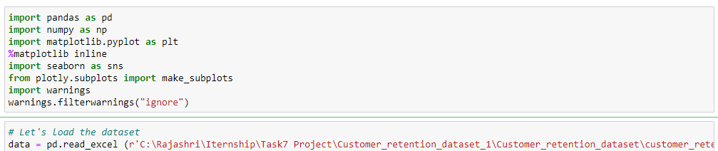

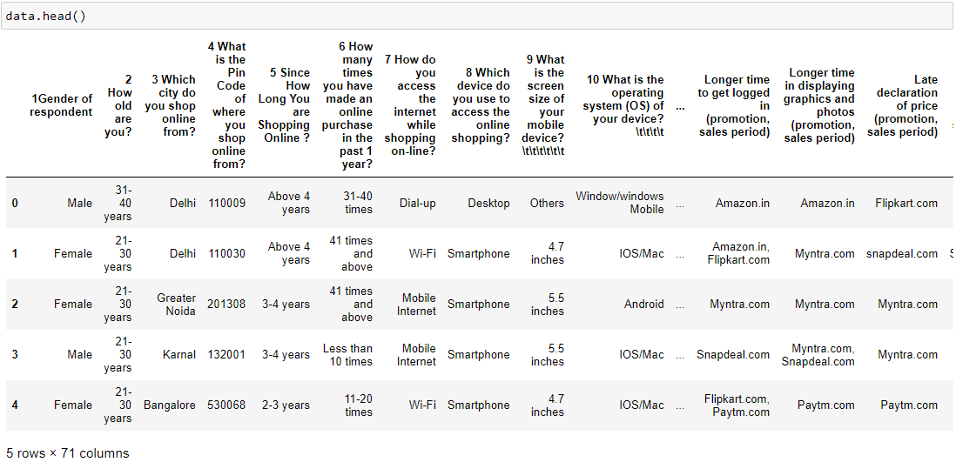

**Replace long column names with short names**

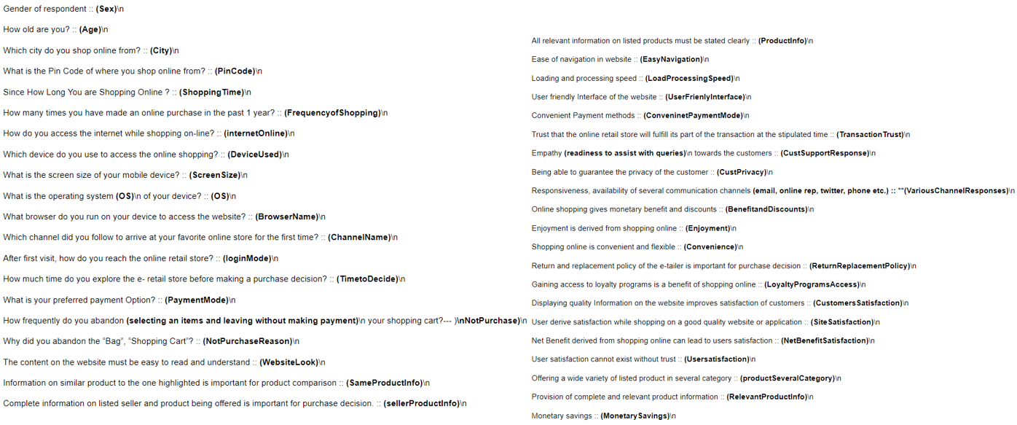

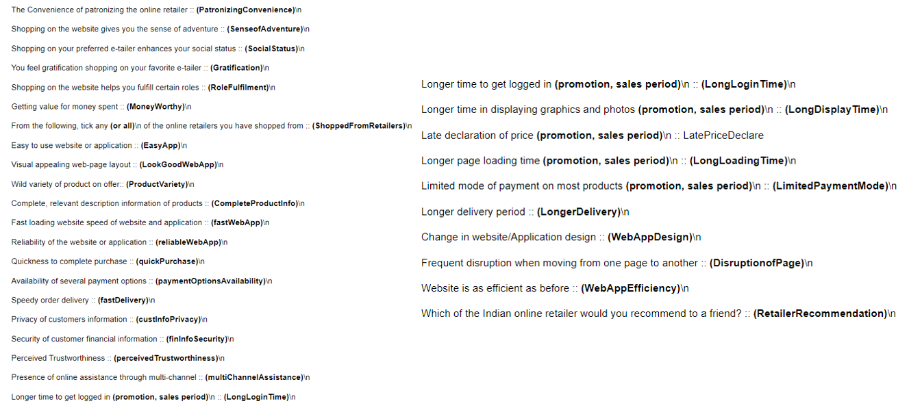

Now dataset looks like

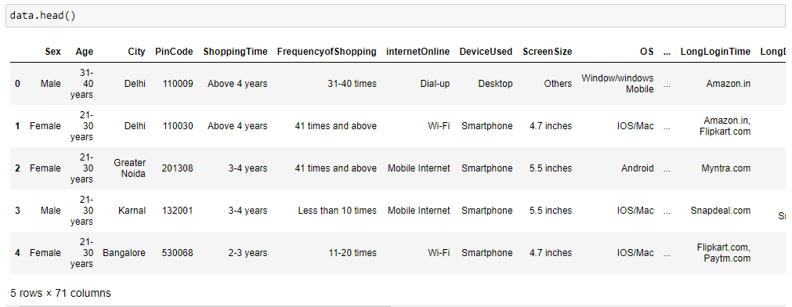

**Exploratory Data Analysis:**

Dataset contains Categorical and Numericle type data.

Above details features details we get the datatypes of features. This gives the information about the dataset which includes indexing type, column type, contains null values and memory usage.

|  |  |
| --- | --- |
|  |  |

#### **Detect the missing values:**

The dataset has missing values we can see with isnull().sum() function and with heatmap graph.

Let's plot the Heat map to visualise the null values, we can observe no Null values present

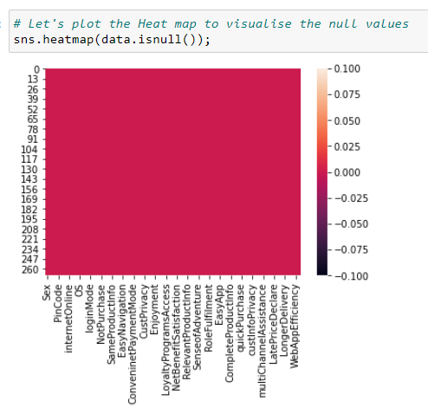

**Statistical Analysis of dataset:**

**We will use describe() method for calculating some statistical data like percentile, mean and std of the numerical values of the Series or DataFrame.**

* Statistical analysis like checking shape, nunique, value counts, info describe etc
* In the database only one numeral datatype rest all are categorical datatypes

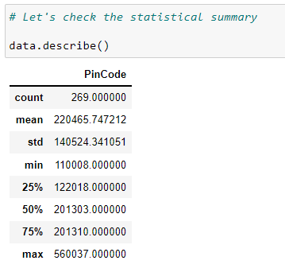

**Data Visualization:**

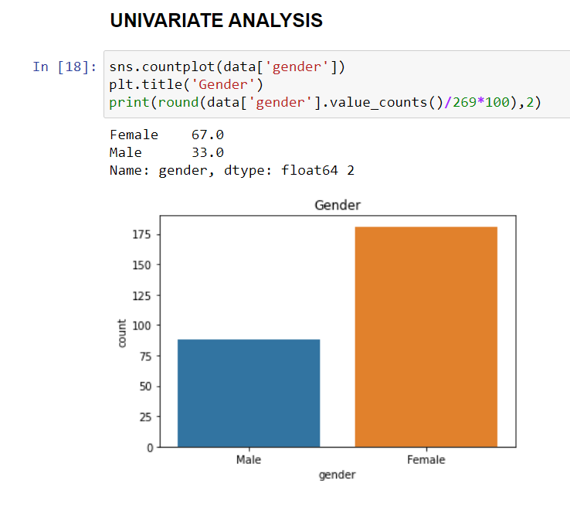

**Observation**:

Out of the total, 33 % are male and 67% customer are female

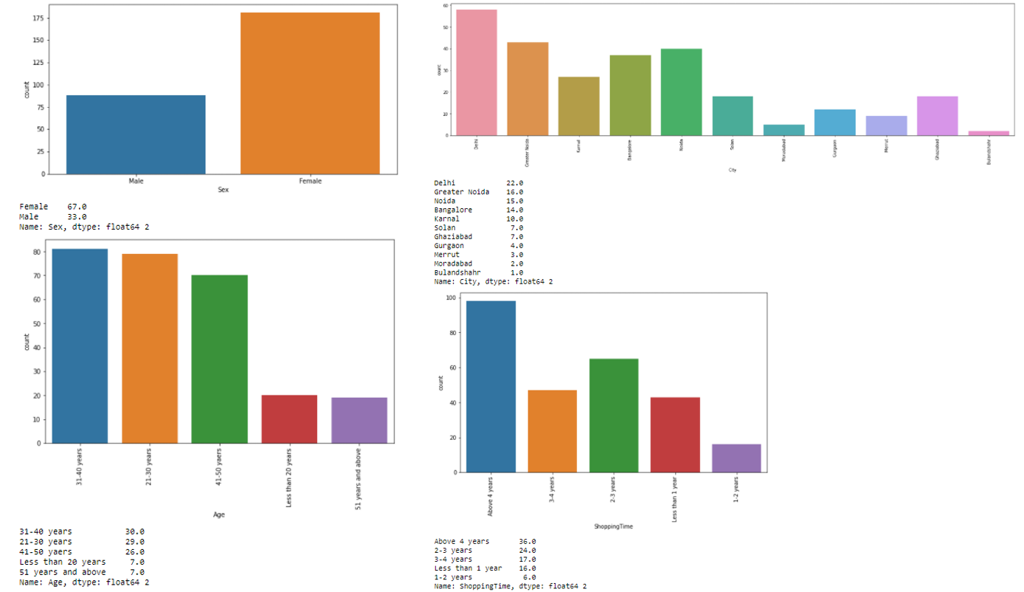 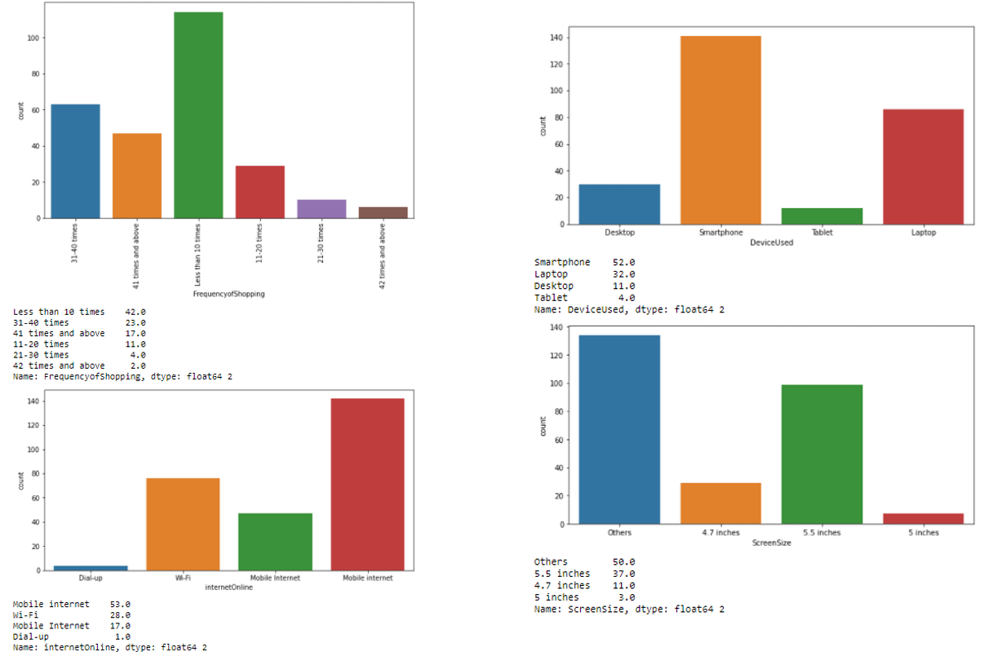 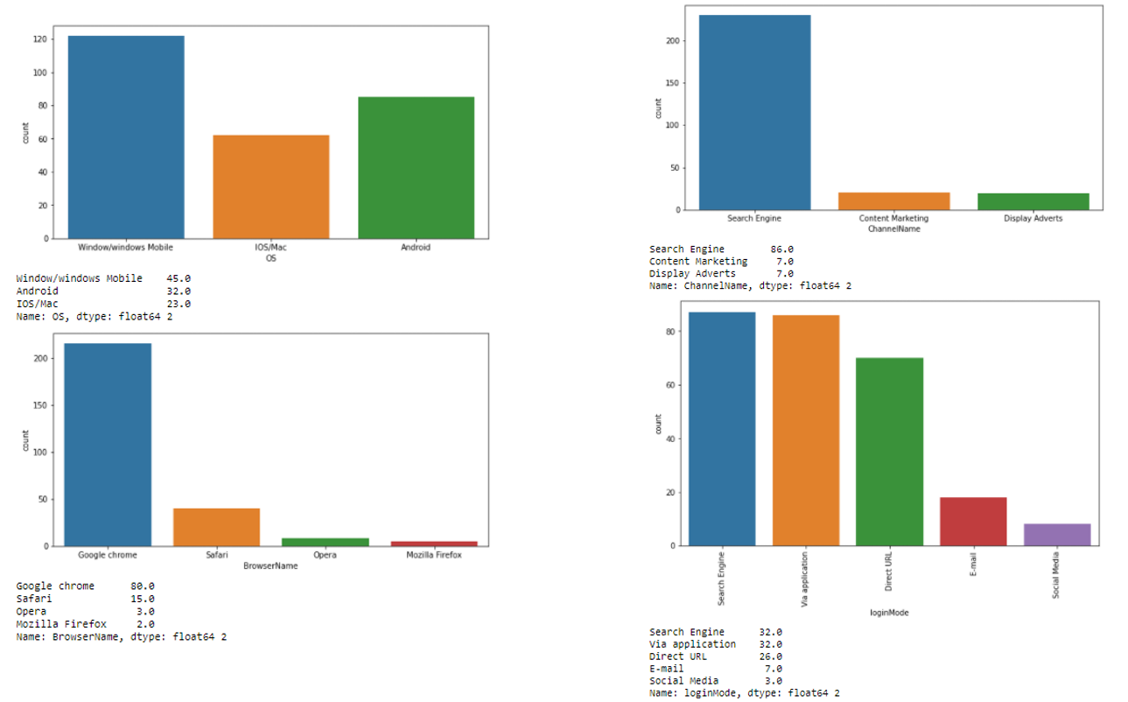 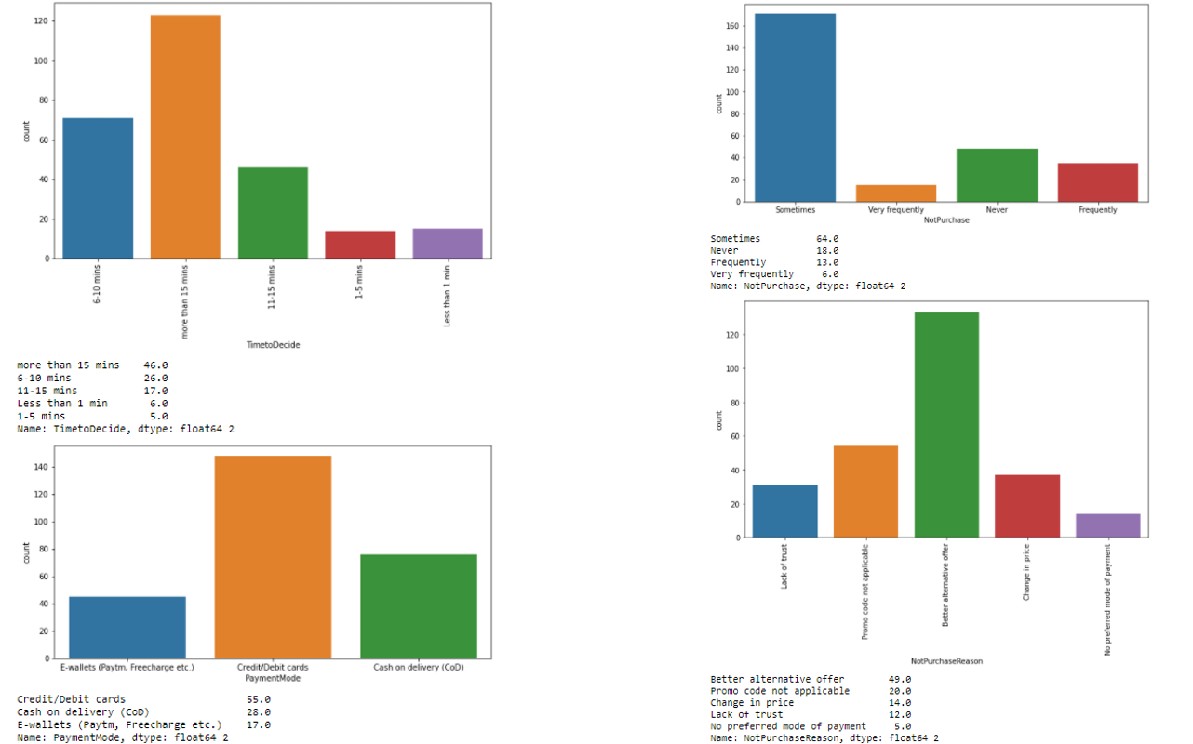 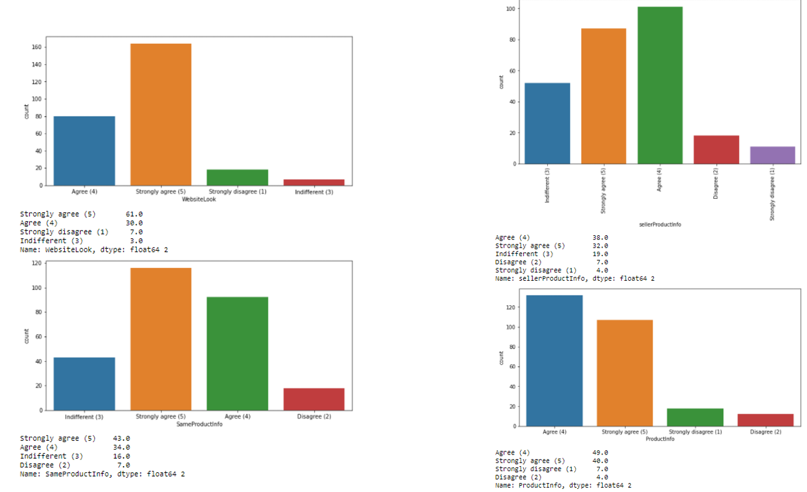

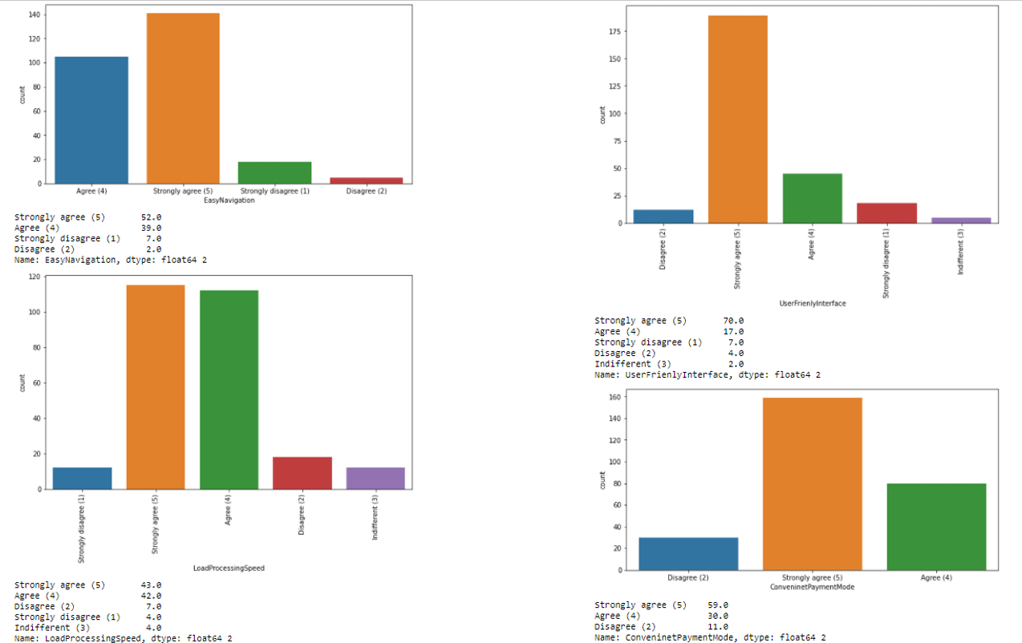 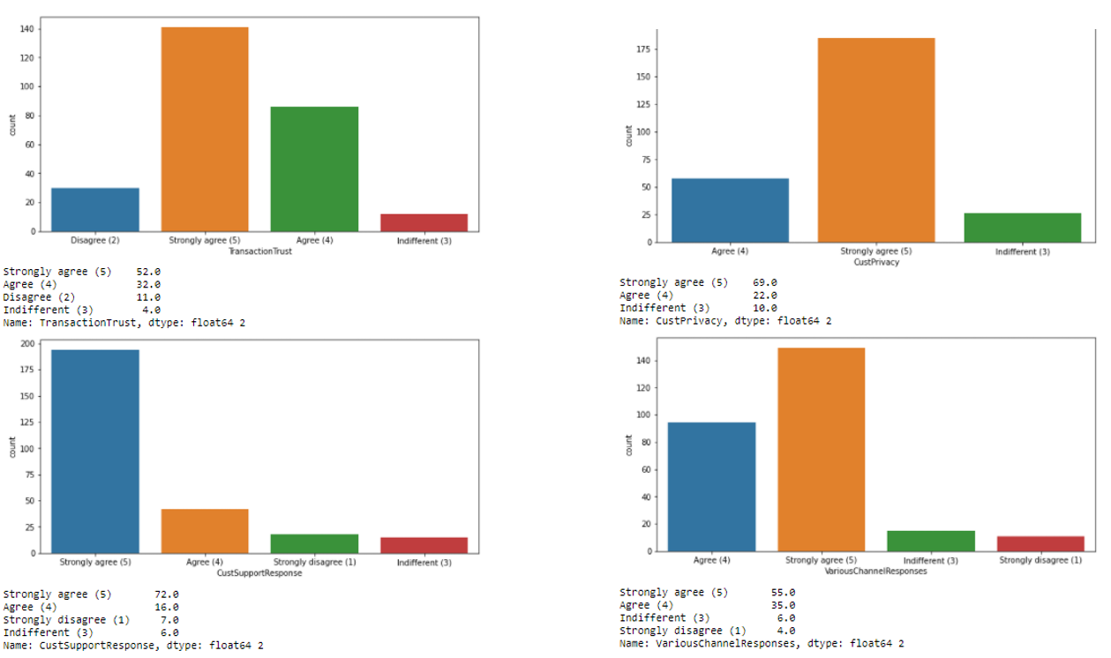 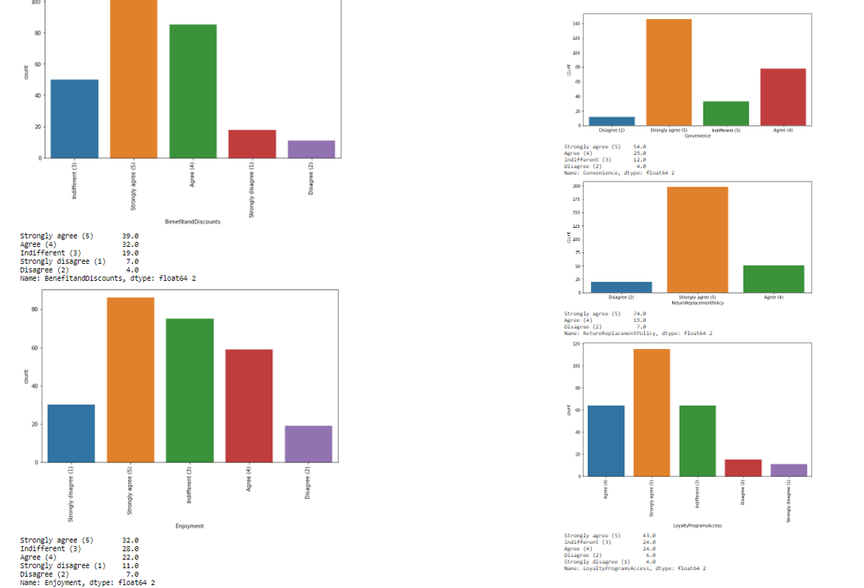 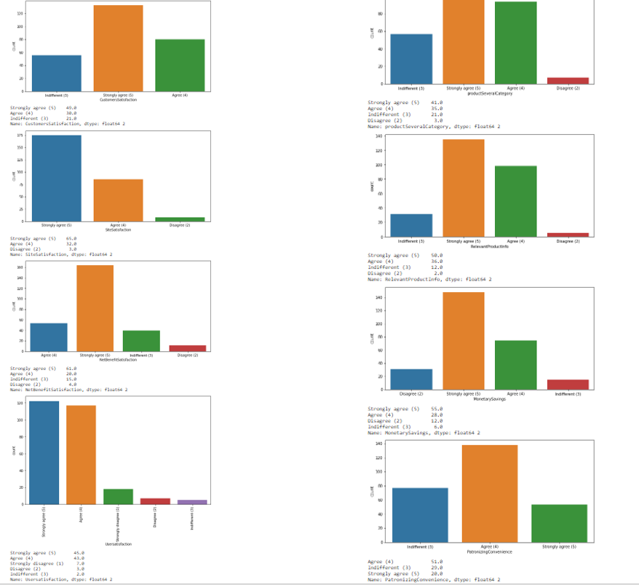 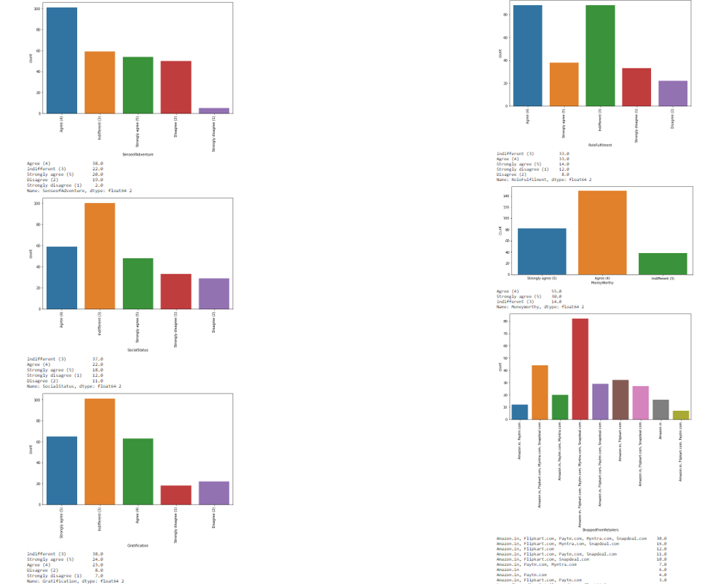 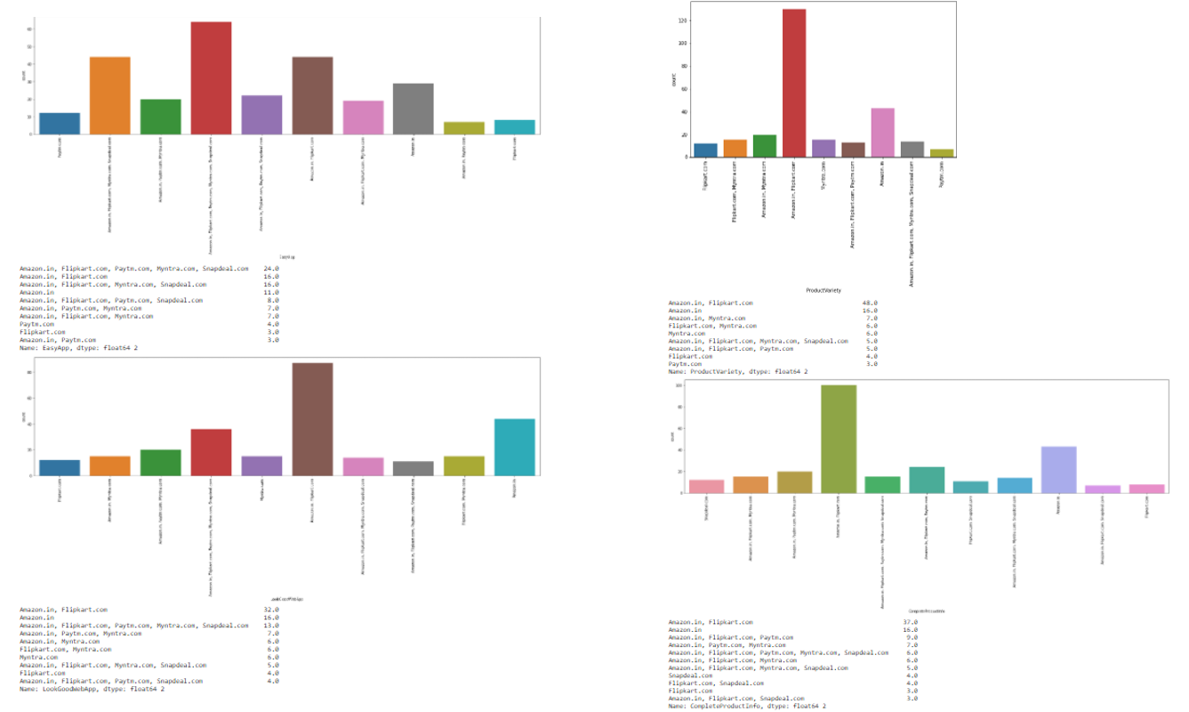 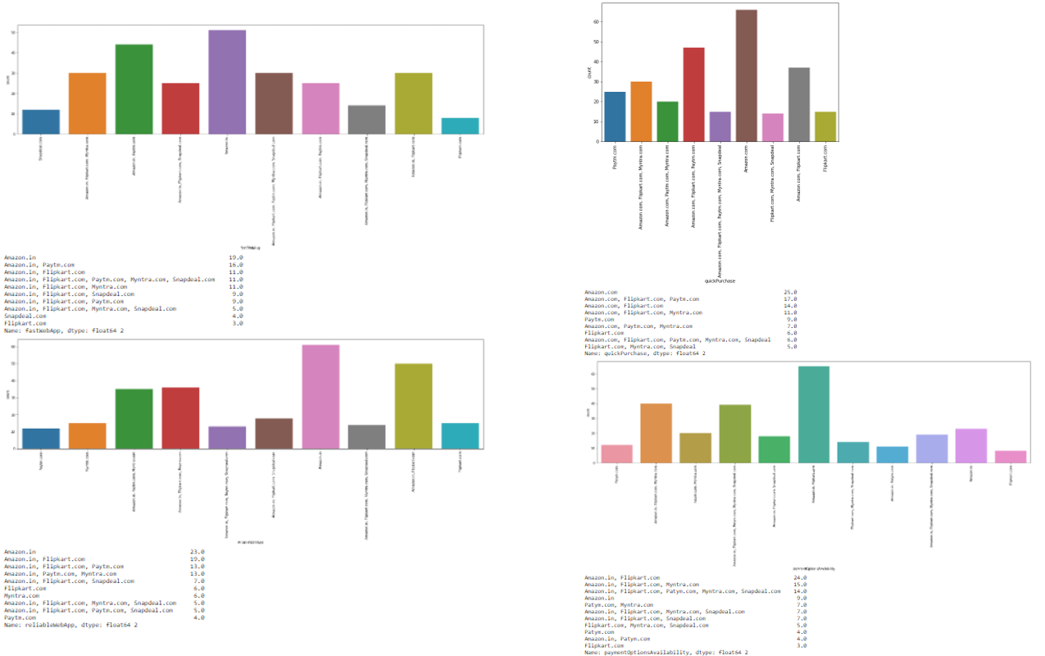 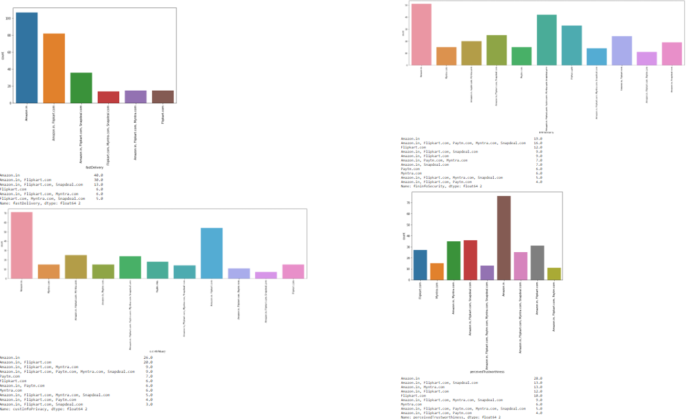 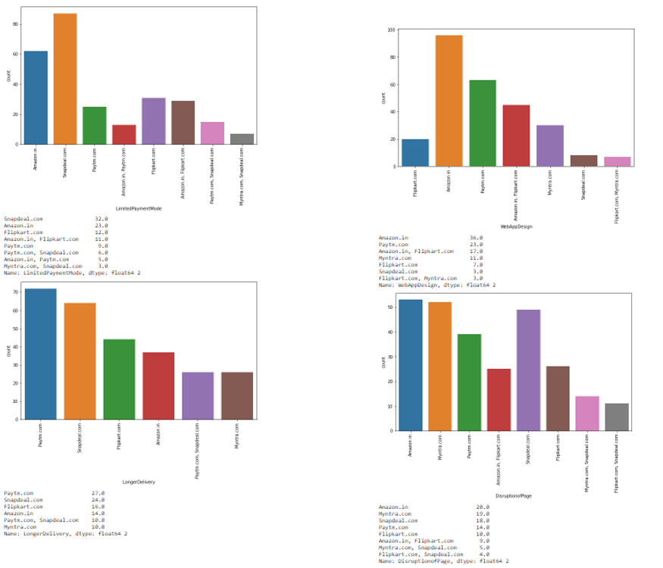 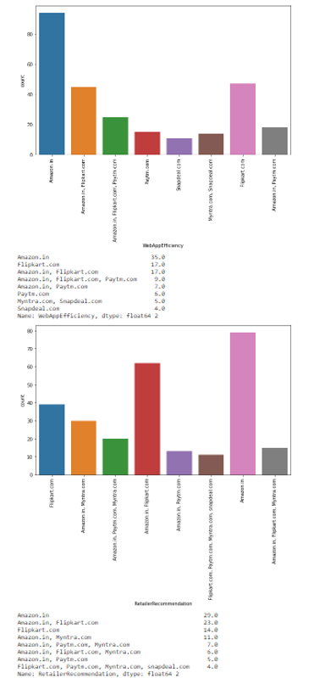

**Observation**:

• 67.0% Female customers are more than 33 %male customers

• Customers between 20 to 50 years shopped more from the online store. 75 % of customers are between 20 to 50

• Delhi, Bangalore, Noida, karnal are the cities with high number of buyers

• 36% customers were found shopping online for more than 4 years

• Mobile internet 53 % of users present, 70% customers used mobile internet and wifi for online purchase

• 52% customers used Smartphone for online purchase, 32% used laptop least 4% used tablet

• 45% customers use Windows phone ,Android 32.0% and IOS/Mac 23.0%

• 80% customers used Google chrome for online purchase which is high

• 86% customers uses Search engine to reach their favorite online store

• 46% customers take at least 15 minutes before making a purchase, 26% take 6-10 minutes only

• 55% customers prefer Credit/Debit cards to make payments ,28% preferred COD and 17 % preferred Wallets

• 64% customers abandon their shopping cart sometimes, 19% abandon their cart frequently

• 49% customers abandon their bag due to better alternative offer, 20% abandon due to promo code not applicable

• 61% customers have strongly agreed to have easy website content which is easy to understand

• 43% customers agree that Information on similar product to the one highlighted is important for product comparison.

• 70% customers agree that Complete information on listed seller and product being offered is important for purchase decision

• 90% customers agree all relevant information on listed products must be stated clearly.

• 90% customers agreed that the website should be easily navigable

• 85% customers had no issues with the loading and processing speed

• 87% customers agree with user friendly website interface. The online stores should invest heavily in creating user friendly apps and websites, so that the customers do not have to work around much and the overall shopping experience is smooth.

• 59% customers strongly agree with the convenient paying methods. The reluctance to make online payments is gradually reducing. The acceptance has been built by addressing the trust issue over time by giving customers an option to pay online or to pay Cash On Delivery (COD)

• 52% customers trust that online store will fulfill its part of transaction at stipulated time

• 85% customers like the organization's readiness to assist with queries

• Being able to guarantee the privacy of the customer: This also got 69% strongly agree. Costumers are concerned about the unauthorized access to their data. Protecting user privacy will enable stores to drive more revenue and gain more customers

• Responsiveness, availability of several communication channels (email, online rep, twitter, phone etc.): 90% customers agreed to it. In case one channel is not available, customers can reach out to multiple channels which again is an important factor. Being able to communicate easily can make the difference in both their shopping experience as well as fulfill business goals of online store.

• 50% agree that online shopping gives monetary benefit and discounts to the customer: Most online shopping sites offer amazing round-the-year discounts. Banks and Digital Wallets have happily jumped on the online shopping bandwagon by providing Reward Points, and instant Cashback offers in addition to brand discounts, which will help to gain new customers

• 60% customers enjoys online shopping

• 84% customers agree that online shopping is convenient and flexible:

• 90% customers agree that return and replacement policy helps them making purchase decision. It is evident from the fact that people cannot actually try & touch the products, they are purchasing before it reaches home and they would want to return or replace in case of dissatisfaction. Online shopping websites should make strategies around easy return and replacement policy if they want to retain their customers.

• Around 50% customers agree that gaining access to loyalty program is a benefit of shopping online

• Displaying quality Information on the website improves satisfaction of customers: 80% customer agreed to it. It means displaying quality information have a significant association with customer satisfaction, and repurchase intentions

• 95% customers are satisfied while shopping on a good quality website

• Net Benefit derived from shopping online can lead to users satisfaction:90% customers agreed

• User satisfaction cannot exist without trust: 85% customers agree that customer satisfaction cannot be built without trust. Trust is important factor to attract e-commerce buyers. So, it is important for companies to learn how to manage consumers' trust

• Offering a wide variety of listed product in several categories: 75% use agreed.

• 86% customers like to have complete and relevant information

• 80% customers agree to receive monetary savings while shopping online

• 50% agree with the convenience of patronizing the online retailer

• 50% customers agree that online shopping give the sense of adventure

• only 30% customers agree that online shopping enhances their social status

• 45% customers feel gratified while shopping with their favorite retailer

• 45% customers feel that shopping online helps them fulfill certain roles

• 85% customers agree they get value for their money while shopping online

Observations from Multiple Options based Questions i.e. related to company name specific parameters, after 47th rows

• Maximum people have shopped from these 5 companies - Amazon.in, Flipkart.com, Paytm.com, Myntra.com, and Snapdeal.com.

• 48% customers says flipkart, amazon shows wide variety of products

• 37% customers like flipkart and amazon in terms of displaying complete and relevant information of the products

• In terms of speed Amazon.in is liked by 90% customers , 60 % like Flipkart , 27% Myntra

• 78% customers trust Amazon to be reliable , 55% likes flipkart , 25% Myntra

• 80% customers likes Amazon's quickness to complete the purchase , 60% likes Flipart's, 30% likes Myntra's

• 86% likes Amazon's delivery speed , 56% likes Flipkart's , 5% likes Myntra's

• 82% customers trust amazon in terms of keeping the privacy of their data, 56% trust flipkart 20% trust Myntra , 12 % trust Snapdeal

• 70% trust amazon in terms of keeping their financial information secured, 56% Flipakrt, 34% Myntra , 21% Snapdeal , 22@ Paytm

• 84% customers believe Amazon perceived trustworthiness, 43% - Flipkart , 33% - Myntra ,Snapdeal 27% Snapdeal

• 86% customers like Amazon in terms of online assistance through multi-channel , 51% -Flipkart ,42% Myntra

• 50% customers agree that Amazon takes longer time to log them in while in sales period/promotions , 39% goes with flipkart, 13% goes with Myntra , 16% Snapdeal

• 46% customers says that amazon takes longer time in displaying photos in sales/promotion , 35%- flipkart, 21% Snapdeal, 14% Myntra, 11% Paytm

• In terms of late declaration of price in promotion/sales 28% goes with Myntra, 21% amazon , 16% flipkart , 18% Snapdeal, 23% Paytm

• In terms of longer page loading in promotion/sales 26% customer goes with Myntra, 23% flipkart, 23% amazon, 24% Snapdeal

• In terms of limited mode of payment on most products during sales period/promotions 41% goes with Snapdeal, 40% -amazon, 23% flipkart, 20% Paytm and only 3% Myntra. Hence Myntra gives most payment options during sales/promotion.

• In terms of time taken in product delivery Paytm has highest votes of 37%, Snapdeal 24%, flipkart 16%, amazon 14% and Snapdeal and Myntra 10%. Hence Snapdeal and Myntra take minimum time for delivery among all.

• 20% customers dislikes disruptions while moving to another page on amazon, 24% on Myntra, 27% Snapdeal, 14% Paytm, 23% Snapdeal

• 61% customers says that amazon website is as efficient as before, 43% for flipkart, 22% for Paytm, 9% for Snapdeal

• 81% customers would like to recommend amazon to a friend, 43% would like flipkart , 22% would like for Myntra , 9% for Paytm and least 4 % would like to recommend Snapdeal

**Data Visualization:**

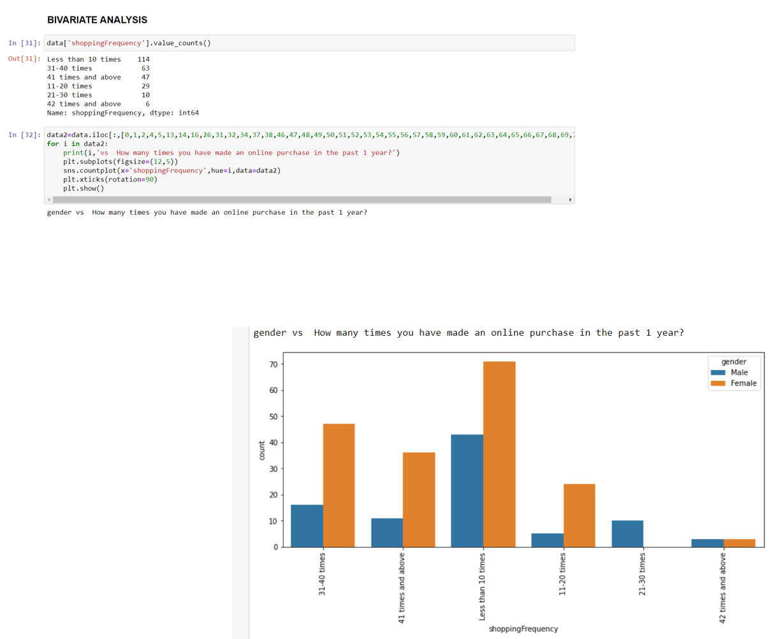

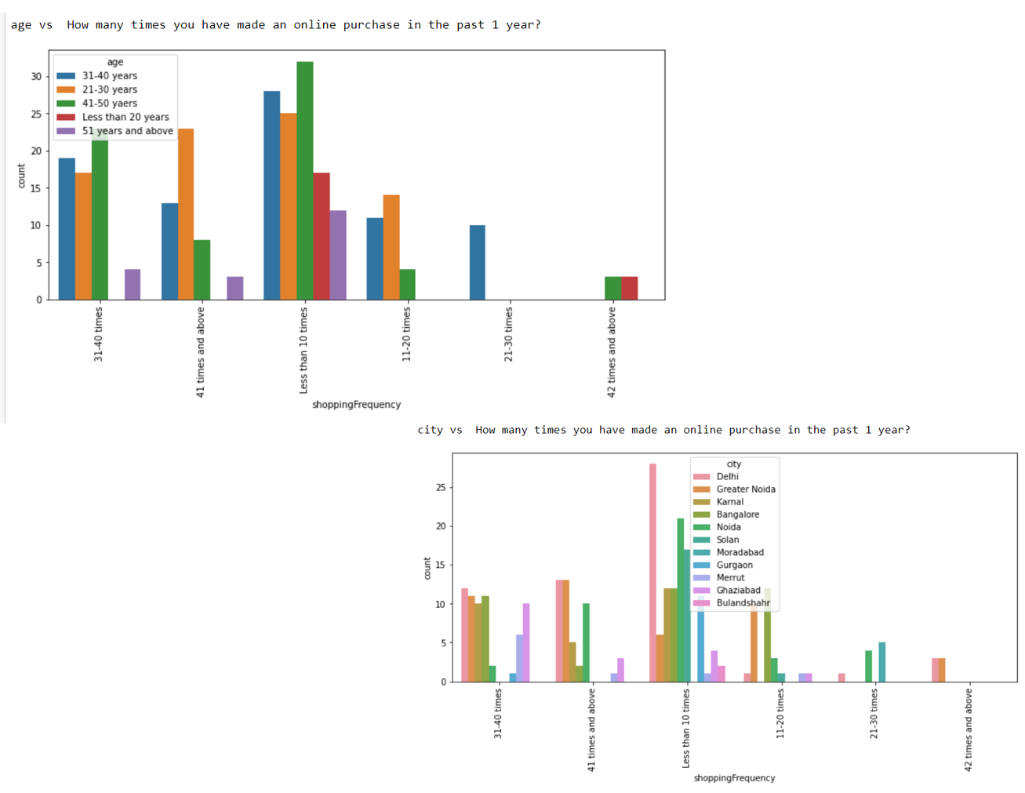 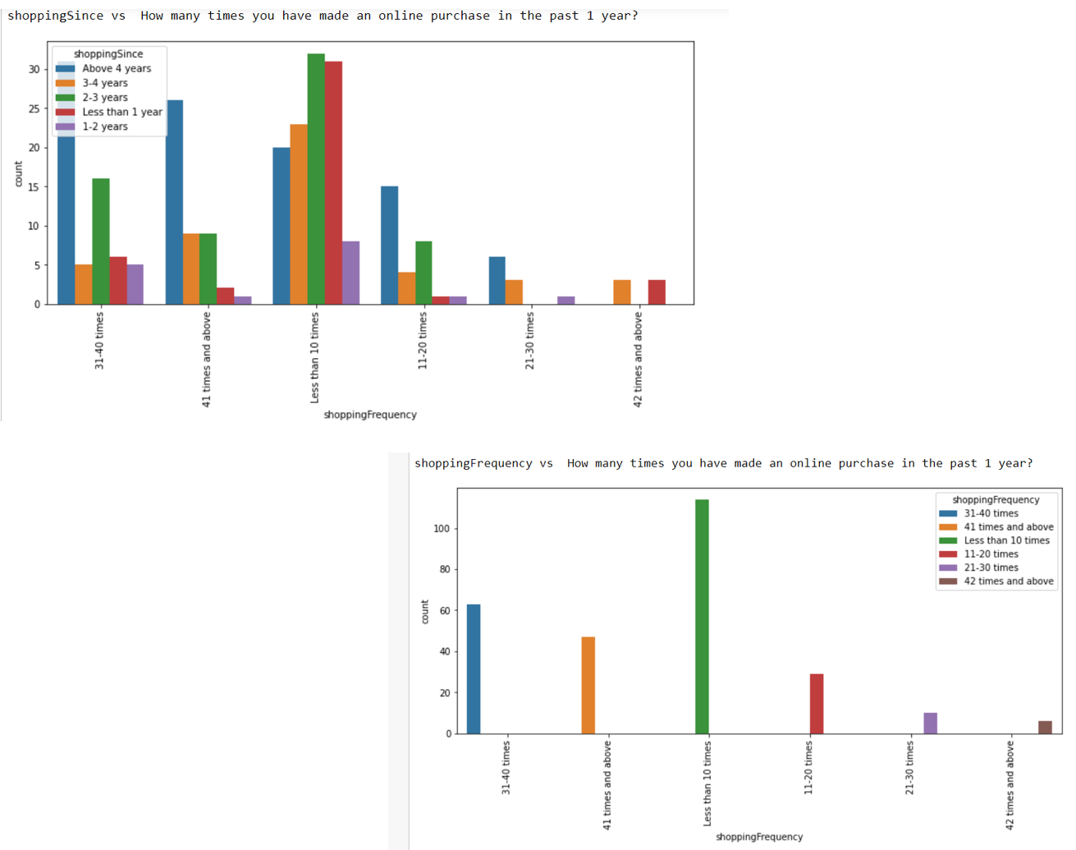 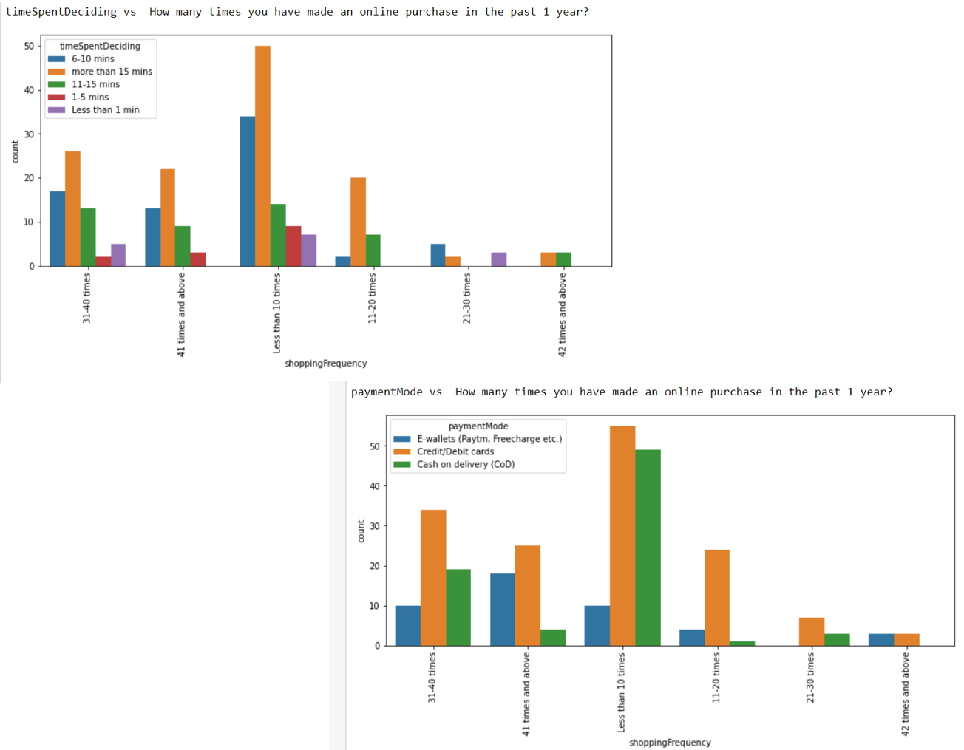 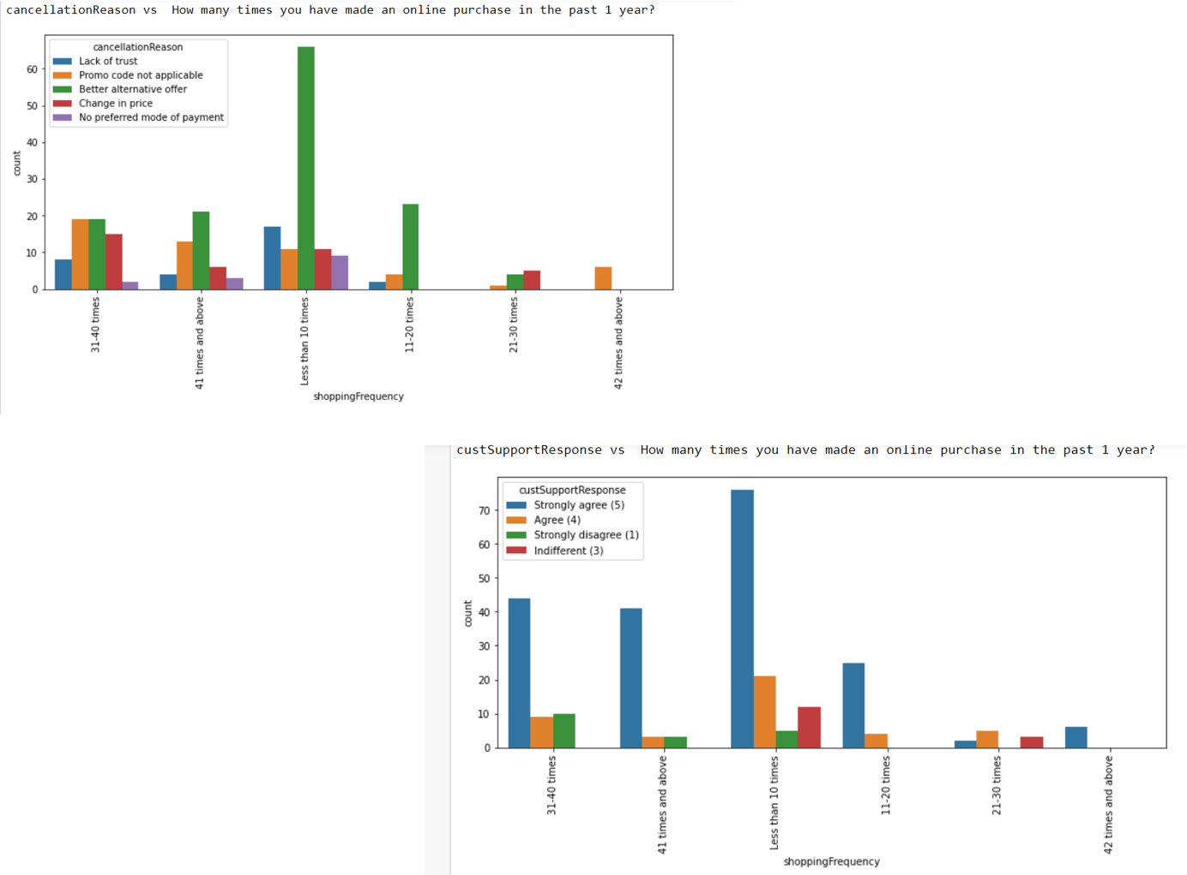 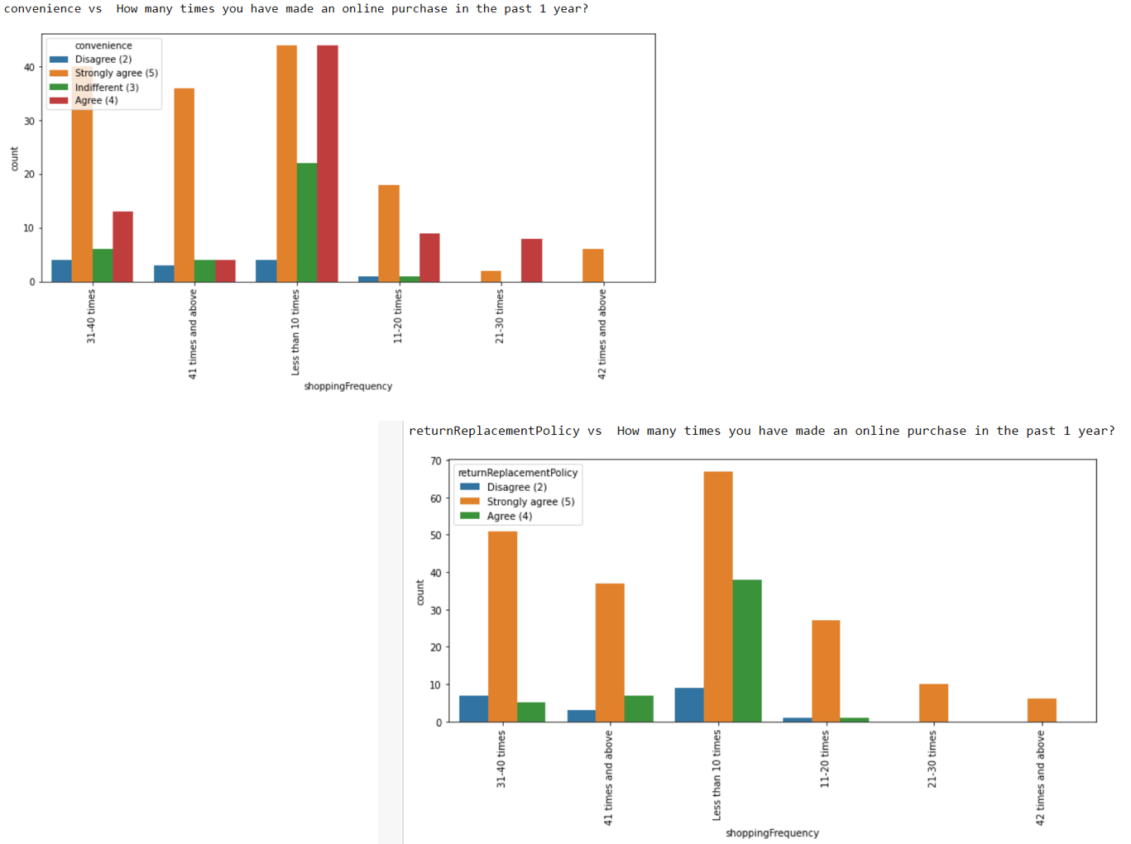 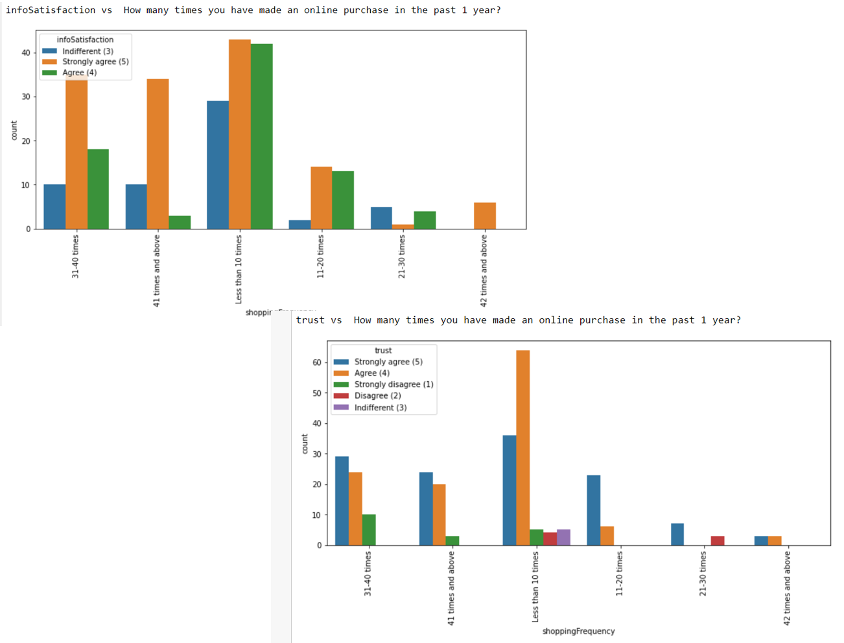 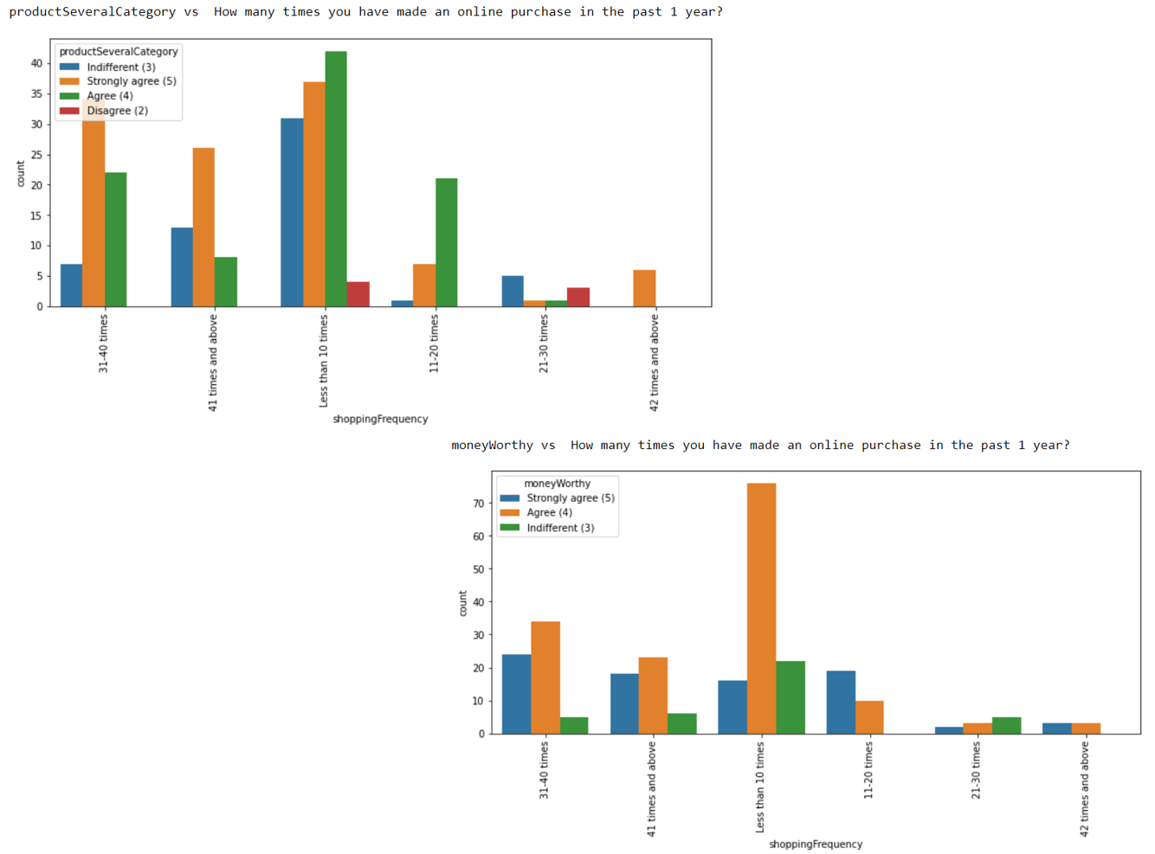 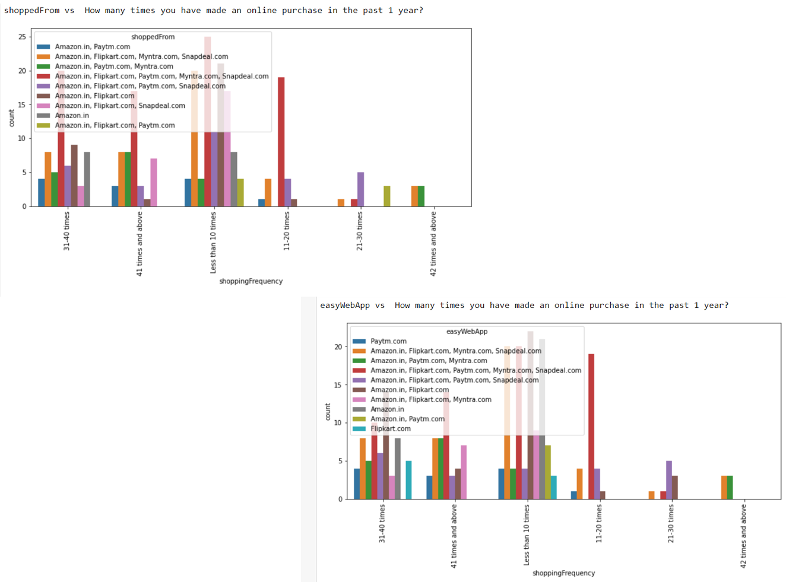 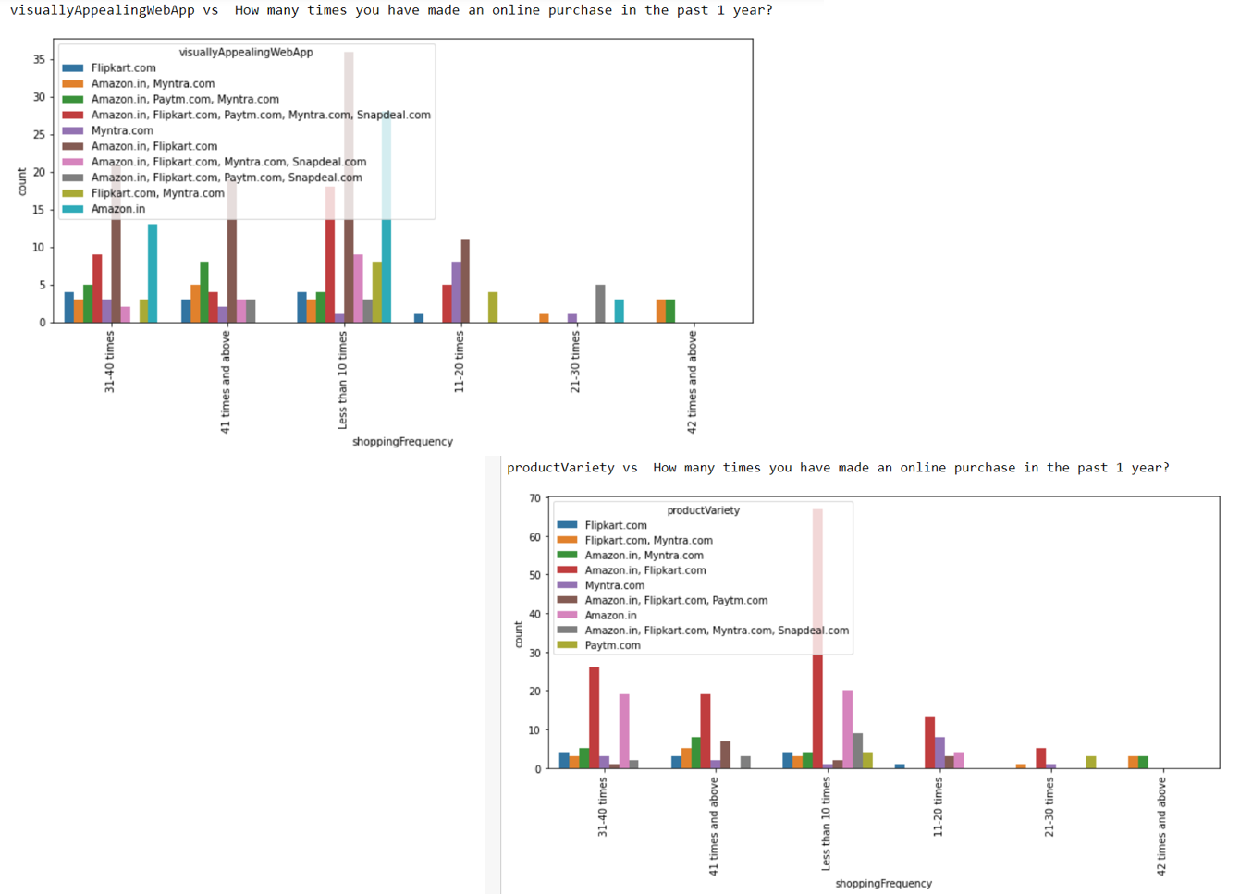 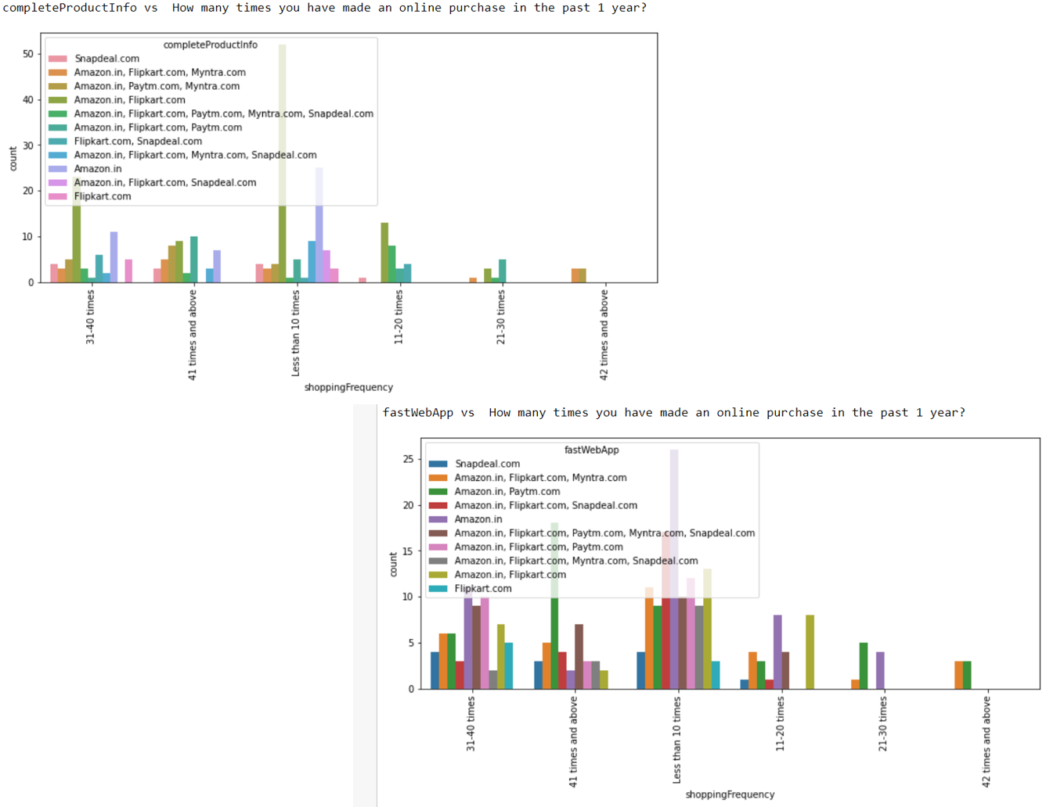 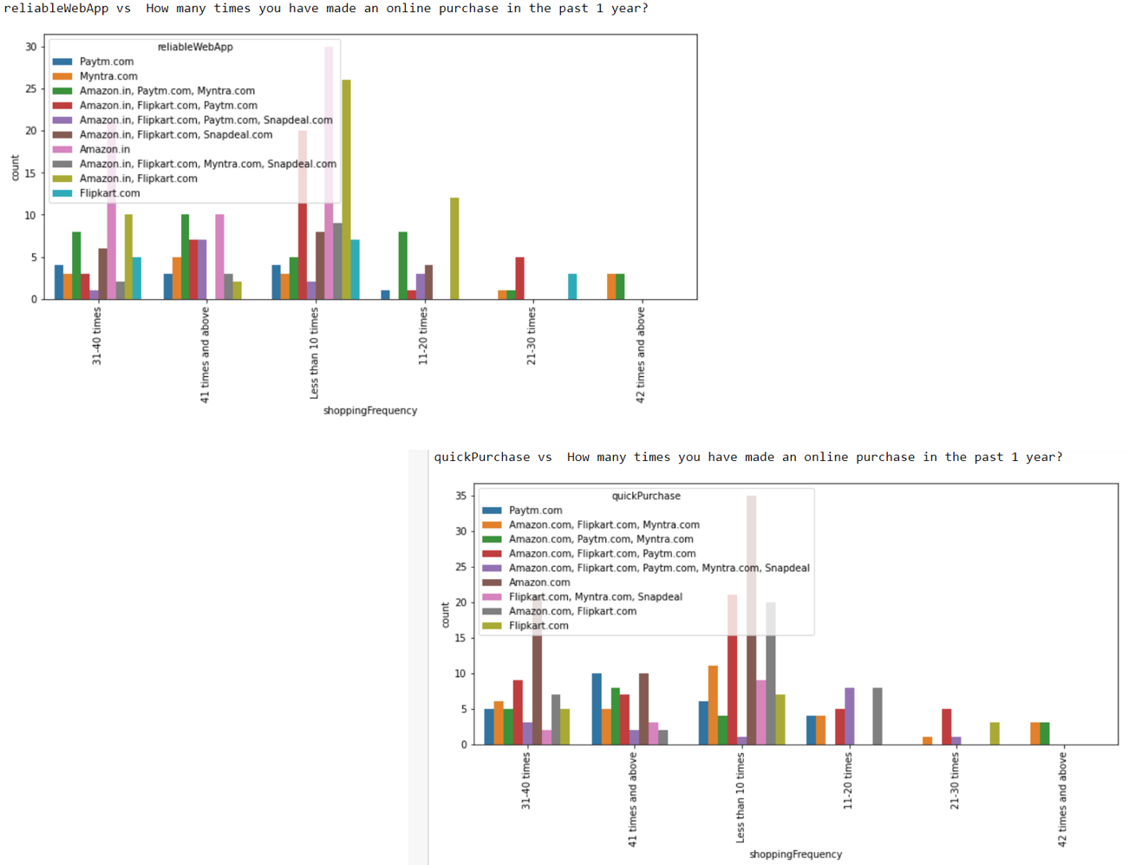 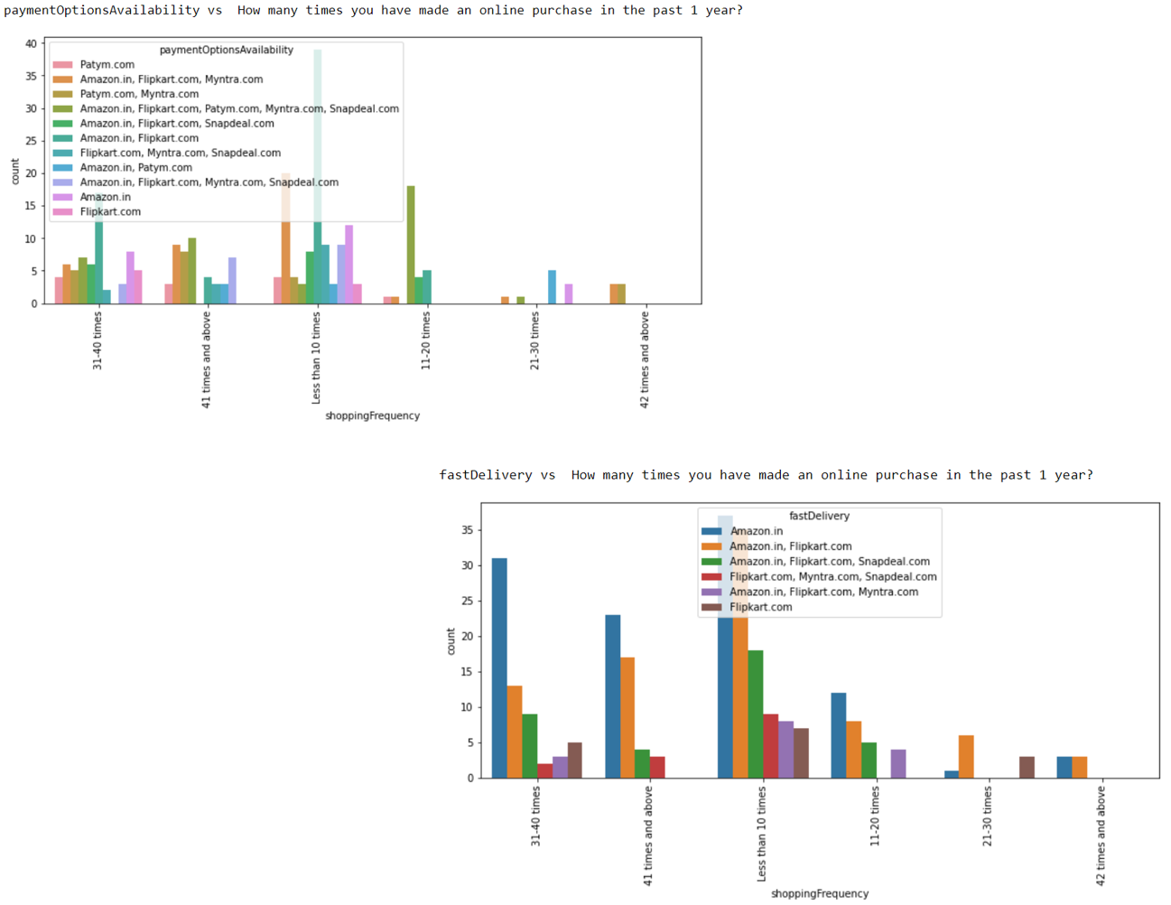 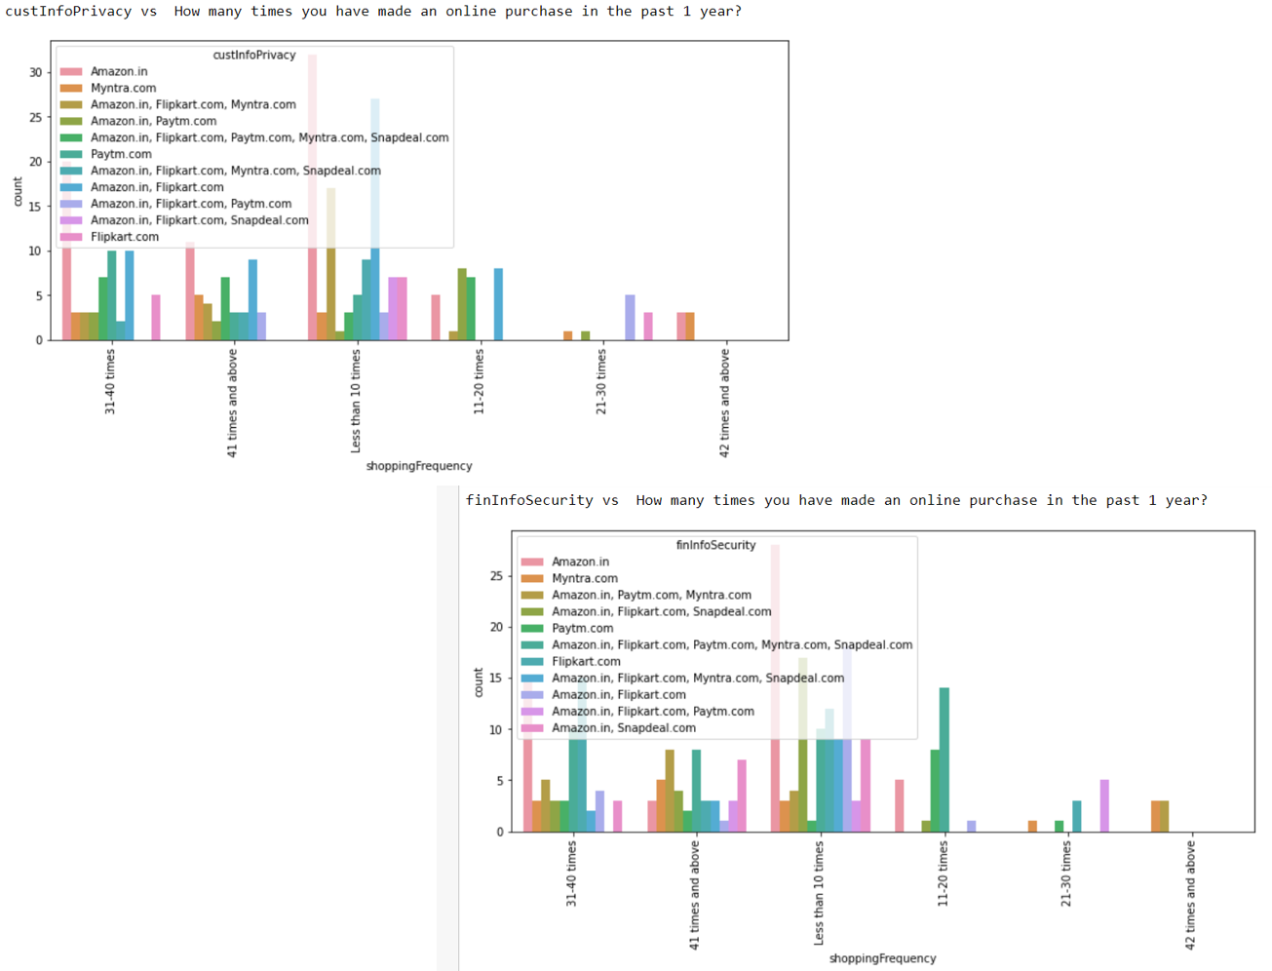 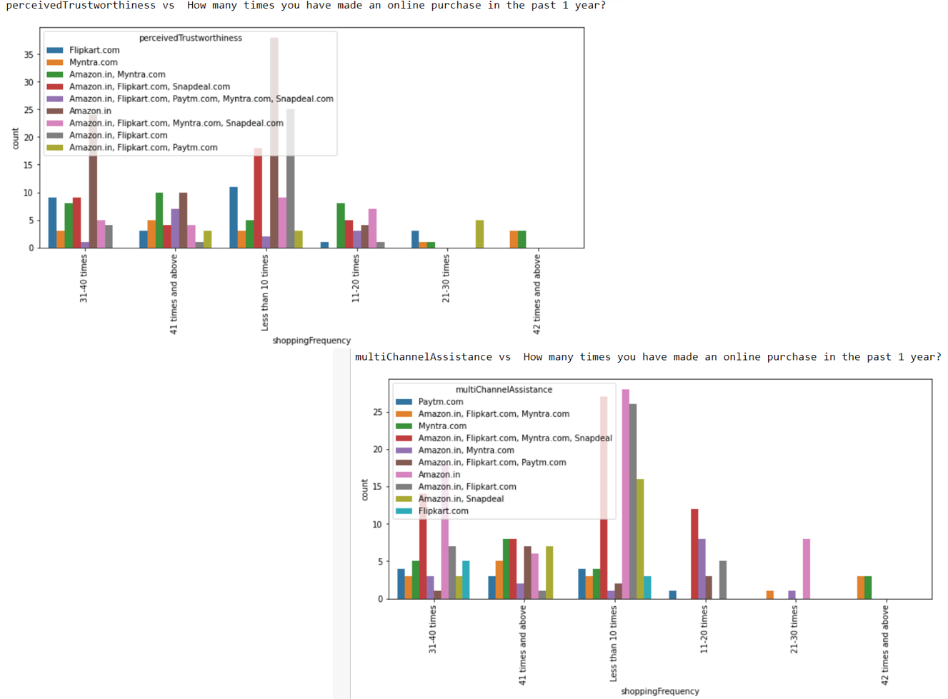 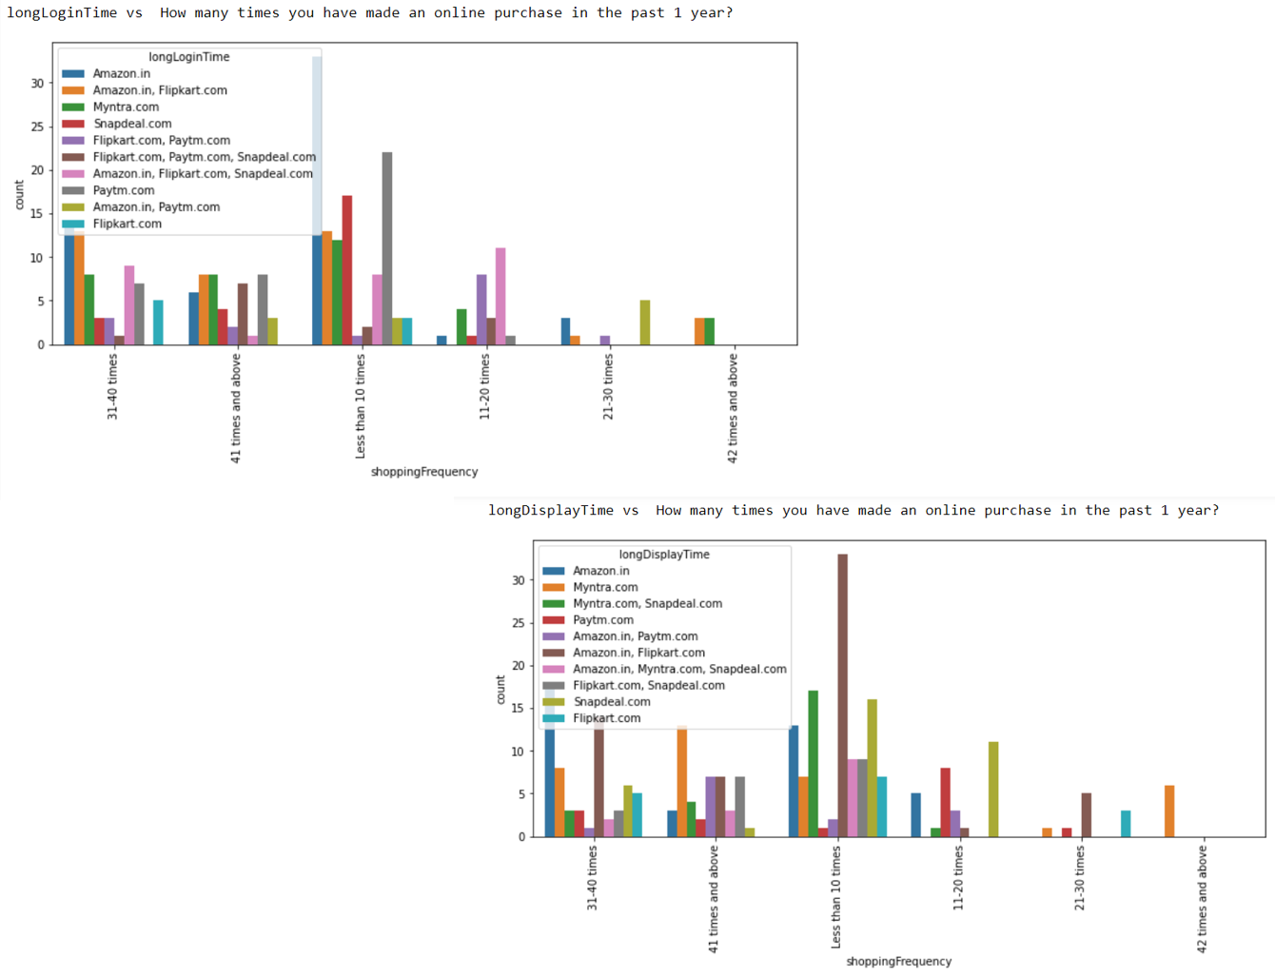 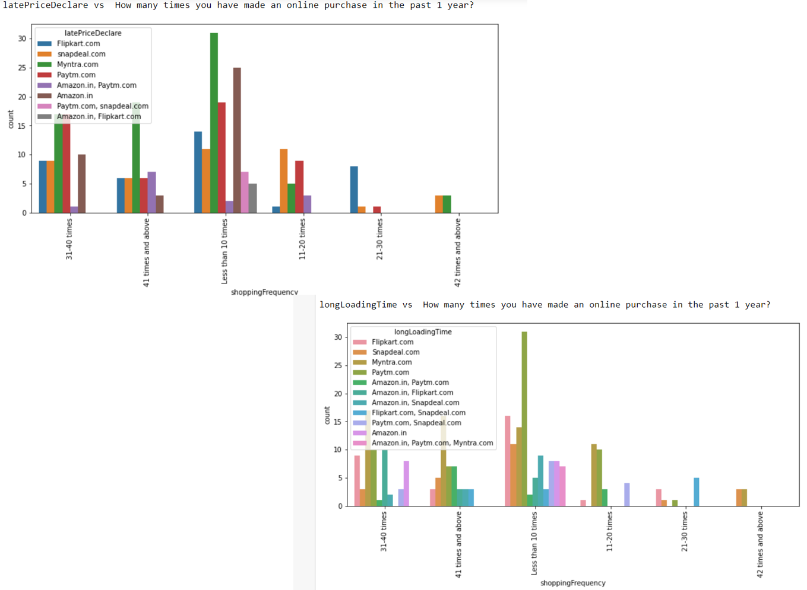 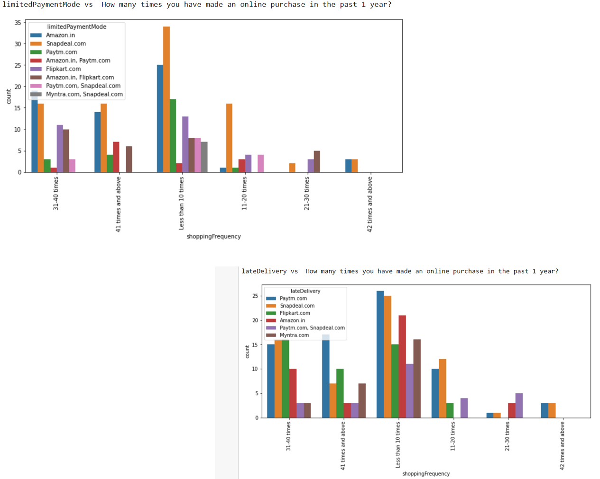 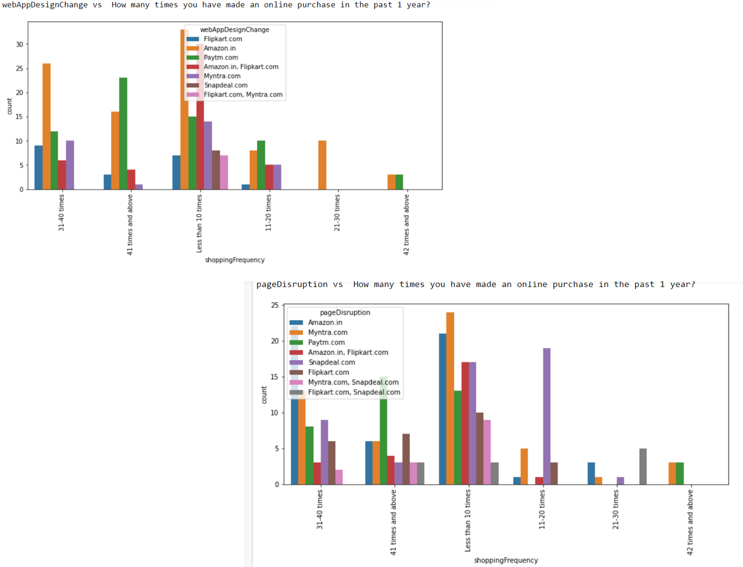 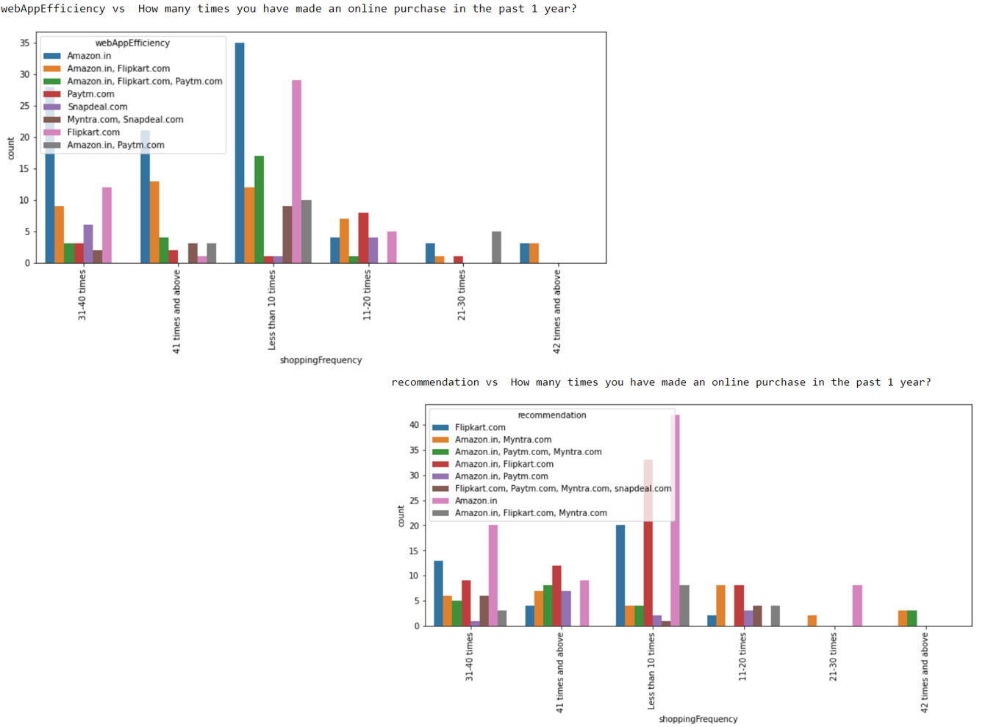

**Observations**

* Highest number of customers like amazon, Paytm and Myntra web page layout
* Highest number of customers like amazon and flipkart in terms of variety of product offered
* Highest number of customers like amazon and flipkart in terms of relevant and complete description of products
* High proportion of high purchase frequency customers like amazon and Paytm in terms of website speed
* Highest reliability is obtained by amazon and flipkart
* Highest number of customers like Amazon in terms of quickness to complete purchase
* In terms of payment option Amazon, Flipkart and Myntra are liked most by the high purchase frequency customers
* Amazon stands apart in terms of speed of order delivery and privacy of customers information
* Most of customers like amazon in terms of online assistance through multichannel
* Most user claims flipkart to take maximum login time during sales/promotion
* Highest customers claims Myntra take maximum time in displaying graphics and photos

**Conclusion**

Customer retention doesn't improve overnight. Customer retention is fickle when customer service is lacking. Few ways to improve customer retention can be as follows:

**Easily navigable :** Customers agreed that the website should be easily navigable. Website navigation is a key to the success of any e-commerce website.

**User-friendly websites: C**ustomers agree with user friendly website interface. It should focus on the user experience by providing shopping categories, filters, and comparison capabilities. User-friendliness requires that your website works on all browsers and devices

**Improve return & refund policy:** Return policies are an essential feature of any ecommerce website. This is another trust-building feature of online selling. ,which reassures buyers that if they are unhappy or just need a different size, the brand is there for them.

When customers are satisfied with a company or service, there is a high possibility that they will share their experience with other people Therefore it is crucial for E-commerce to take into account their customer satisfaction because this will retain customer loyalty as well as attract potential customers.

